# E-Commerce Website

***Functionalities:***

* Login / signup Page
* Search Functionality
* Filter Functionality
* Admin Dashboard
* User Dashboard
* Payment Integration

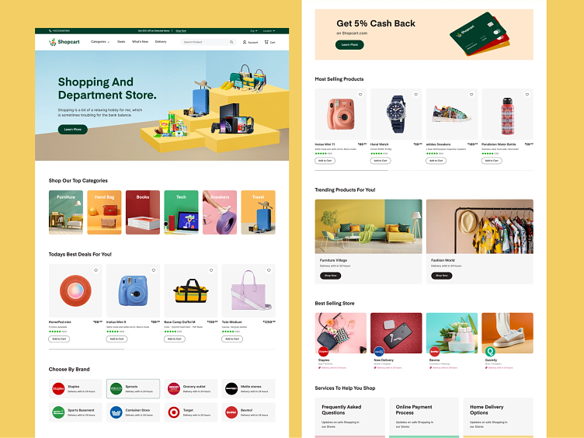

Muhammad Tayyab  
22-Arid-945  
BSSE 3A Morning  
Web Technologies